CS 1050 Technical Documentation

Click table of contents below to refresh after adding more headings
Overview
General Resources
SD01 Software Development and Tools
Version Control
IDE and Debugging
Analyze requirements
Design and Testing Plan
Implement Quality Documented Code
Module 1: Programming Fundamentals and Tools
Heading 2 Example
Topic heading 2 for
Heading 3 Example
Module 2: Predefined Classes, Methods, and Decision Structures
Heading 2 Example
Heading 3 Example
Module 3: Loops and Methods
Heading 2 Example
Heading 3 Example
Module 4: Arrays
Heading 2 Example
Heading 3 Example
Module 5: Classes and Objects
Heading 2 Example
Heading 3 Example

Overview
When you add information in your own words demonstrating your understanding. Do not use exact words from lectures or images from lectures.

DOs and DON’Ts
DO: Provide clear and simple explanations in your own words (be concise)
- Use short sentences, small paragraphs
- Use lists and tables to organize information
- Use standard industry terms but explain in simple language
- Use AI Tools to help you learn but use lectures first
DON’T copy my explanations from the slides as yours.
DO Use Code Snippets and Visuals to reduce lengthy explanations:
- Include examples you explored or created
- Include comments to describe parts of code
- Include Screenshots such as from your debugger
- Include your own drawings such as for memory, arrays, etc.
- Include images you have AI create (cite that AI created)
- Include images from the Internet with the link
DON’T use my slides as your image and explanations
DO Include Resources that give steps or help explain concepts
- You can include resources given in the lecture or find your own but
  - Include website link with summary
  - Include links to videos with summary of content
DON’t use AI to create your technical documentation.

General Resources
- Your first source should always be your course lecture slides and documents or links to information in the lectures
  - F26_CS1050_Student_Course_Resources
  - Java Environment Setup
  - Introduction to Programming with Java - use the sections shared with you to practice ideas from the lecture.
- Next resource is to see Deb or learning assistance during office hours
- If you're unsure whether a source is trustworthy, ask your instructor first. ⚠️ Avoid These Sources
- TPointTech https://www.tpointtech.com/
- W3Schools – Java, syntax, data types, etc.:
https://www.w3schools.com/java/
- Sites without a known author or date
- AI-generated blogs that do not cite documentation
- Use of AI should be last as it will probably give you information you haven’t learned or understand. It is expected you will be documenting concepts from class and book using your code examples.

Other Tools you should use:
- Eclipse
- Visualize Java Code - used to step through code and edit code

SD01 Software Development and Tools

Version Control
- Use version control management tools (Git/GitHub) to manage and document development with GitHub Desktop.

IDE and Debugging
- Write and debug programs in IDE (Eclipse)

Analyze requirements
Analyze requirements(user stories and acceptance criteria) to break problems into smaller testable tasks

Design and Testing Plan
- Apply Test-Driven Development (TDD): Create unit test cases, design algorithms in pseudocode, implement code (structured, readable and documented), debug and unit test incrementally
- Develop a documented plan by creating unit test cases and algorithm designs
- Use UML to design and implement multiple class programs.

Implement Quality Documented Code
- Apply Java naming conventions for variables, constants, methods, and classes.
- Write comments at top of file and inline comments to document code.
- Use constants and variables and avoid hard coding literals
- Document method code following javadoc commenting
- Use Single Responsibility Principle (SRP) and Do Not Repeat Yourself (DRY) to implement modular, readable and testable solutions

Module 1: Programming Fundamentals and Tools
Add the information to demonstrate the following objectives and organize with headings:
- Mixed number (doubles and integers) operations
- Standard output using System class and print methods.
- Identify different types of Errors
  - Syntax error. Include a screenshot of your IDE showing there is a syntax error
  - Runtime error. Include a screenshot of your IDE showing
  - Logical errors.

Variables and Constants

Variables
- Variables can be changed throughout the code

Constants
- Constants are fixed values that can't be changed throughout the code and are using the data type static.

Declaring variables
- To declare a variable, state what data type of variable you want it to be before your given name of the variable.

Initializing variables
- To initialize a variable, use the equals sign (=) after the given name of the variable, followed by whatever you have declared the variable to be.

Assigning Variables
- Assigning a variable is whenever you set a variable to a new value similar to initializing variables.

(ex)
// declares RANDOM_MULTIPLIER as an int and as a constant which can't be changed

final int RANDOM_MULTIPLIER = 100;

// declares number as an int and initialized to a random number multiplied by RANDOM_MULTIPLIER

int number = (int) (Math.random() * RANDOM_MULTIPLIER) + 1;

Scanner keyboardInput = new Scanner(System.in);

System.out.println("Guess a magic number between 0 and 100");

int guess = -1;
while (guess != number)

Comp Math

Order of Operations
- PEMDAS

Inteager division
- Is indicated by the forward slash (/) and returns the product of a number divided by another number, and drops the decimal unless declared as a double.

Moudlus operator
- Is indicated by the percentile sign (%) and returns the remainder of two numbers divide by each other.

Memory and data types

Primitave data types
- Integer
  - Is allocated in memory 32 bits or 4 bytes, and only holds a single variable, and can be assigned to a double
- Double
  - Is allocated 64 bits or 8 bytes and can hold decimals and integers, but can not be assigned to integers

Implicit assigning
- is done for you if the data type is larger than the variable that is assigned to it.

Explicit assigning
- Is done when you are assigning a larger data type to a smaller data type via casting ( (int) ).

Error types

Ex:

Module 2: Predefined Classes, Methods, and Decision Structures
Add the information to demonstrate the following objectives and organize with headings:

Classes

System
  - .in
    - Returns the user input as a string
  - .out
    - Returns a string of whatever we put in the parentheses

Scanner
  - .next
    - Returns the next input as a string
  - .next.charAt
    - Returns the next input of a character at a specified point of the string as a char
  - .nextInt
    - Returns the next input as an integer
  - .nextDouble
    - Returns the next input as a double
  - .close
    - Closes the scanner that you opened. place at the end of the code
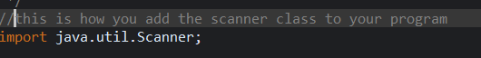

String
  - .toUpperCase
    - Returns the entire entered string as Uppercase letters and as a string
  - .toLowerCase
    - Returns the entire entered string as Uppercase letters and as a string

Character
  - .toUpperCase
    - Returns the entered string as uppercase letters and as a char
  - .toLowerCase
    - Returns the entered string as lowercase letters and as a char

Math
  - .random
    - Returns a random number between 0 and 1 and as a double

Data types

Strings
  - A string is a larger data type that can hold an array of characters and is made up of characters

Char
  - A char is a smaller data type and can be held in a string and is made up of a single character

Booleans and operators

Booleans
  - Booleans are true or false statements and can only be one or the other

Relational opps
  - Are used to narrow down ranges of data, ==, <=, >=

Logical opps
  - Are used to combine or modify Booleans, &&, ||, !

Scope

Variable scope
  - The scope of a variable is confined to the brackets it is in and can be used within deeper set brackets, but can't be used in outer brackets

If statements

If Else
  - You use if – else to check a range of data and produce an output based on whether the data was valid or not

Multi-way if
  - You use multi-way if statements to test multiple different cases of valid data to produce different outputs for each case
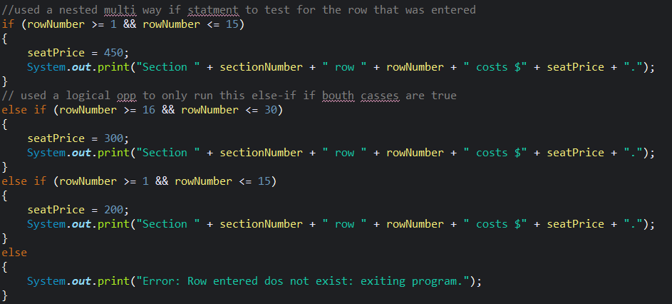

Nested if
  - You use nested if statements to narrow down data further

Switch statements
Are used when you want to test for vary specific valid inputs and variables, and can only be true or false, and you cant use logical or rational operators.
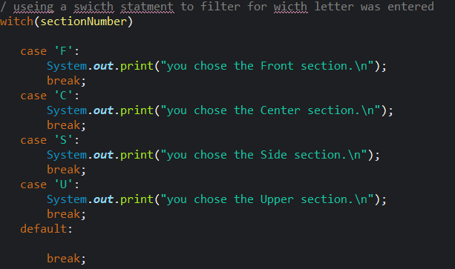

Module 3: Loops and Methods
Add the information to demonstrate the following objectives and organize with headings:

Loops

For loops
  - Used when you know the amount of iterations you are going to do
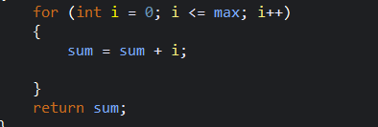

While loops
  - Used when you don’t know how meany times the code will run
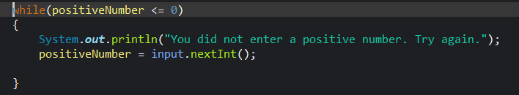

Do While
  - Used if the code will run at least once but could run forever
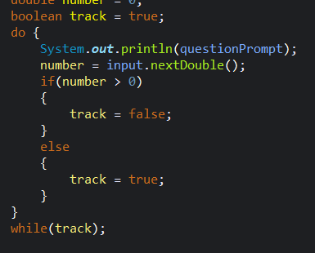

Sentinel values and Boolean flags

Boolean flags
  - Are used to stop while loops so they don’t go on forever and are changed in the loop

Sentinel value
  - Are used to trigger Boolean flags

Method variable scopes

Variables are only useable in the method they are declared in unless transferred as apart of a methods arguments

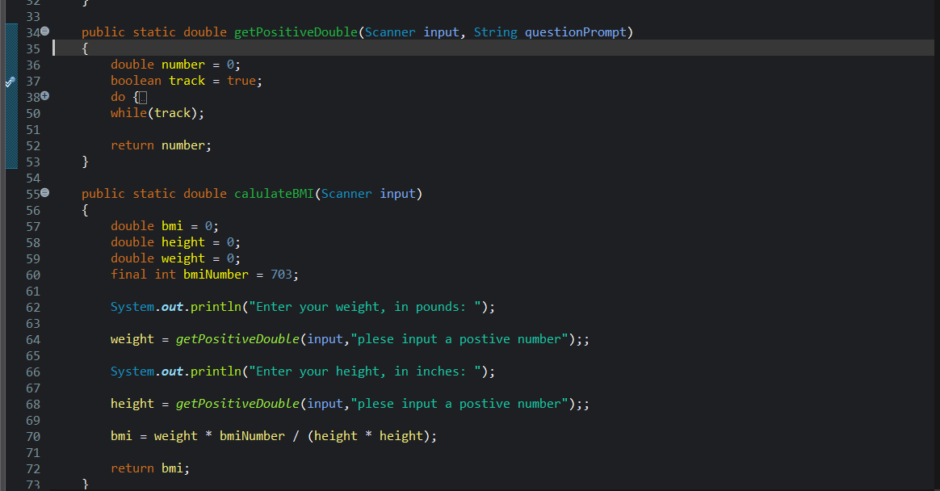

Module 4: Arrays
Add the information to demonstrate the following objectives and organize with headings:
- Reference variables, array memory, and out-of-bounds issues.
- Passing arrays by reference to and from methods
- Trace memory during method calls to distinguish reference variables vs. primitive variables, stack vs. heap memory allocation.
- Design algorithms for processing arrays.
- Designing methods that operate on arrays using loops.

1D Arrays

Declaring, Allocating, and Initializing
  - Declaring an array is the same as declaring a variable, but after the data type, put [] to state it's an array.
  - When an array is declared, only a reference is made; you allocate memory by using the (new) keyword and setting the size. The memory allocated is made in the heap.
  - You can initialize an array in two different ways. You can either do it when you declare it by using {} and adding the data manually. If you do this, then you don't need to use the (new) keyword; the other way is by using [] and setting the length of the array, and adding the data later.

Module 5: Classes and Objects

Add the information to demonstrate the following objectives and organize with headings:
- Use classes to define blueprints for creating objects that combine data (fields) and behaviors (methods).
- Define and implement constructors, including default, parameterized, and overloaded constructors, to initialize objects in different ways
- Encapsulation using access modifiers and getters/setters to protect and manage private data.
- Reference variables for objects, stack/heap diagrams.
- Arrays of objects
- Simple file input/output
- Design Implement and Test Java classes that model real-world problems

Heading 2 Example

Heading 3 Example

